The Complete Agentic AI Engineer

Slides for the 6 weeks

I created these using beautiful.ai, which absolutely lives up to its name! Rather than exporting to PDF, I’ve decided to link to the live slides, so that you’ll have instant access to any updates.

Here’s the curriculum (Week 1 on bottom row), with links to all the slides on the next page.

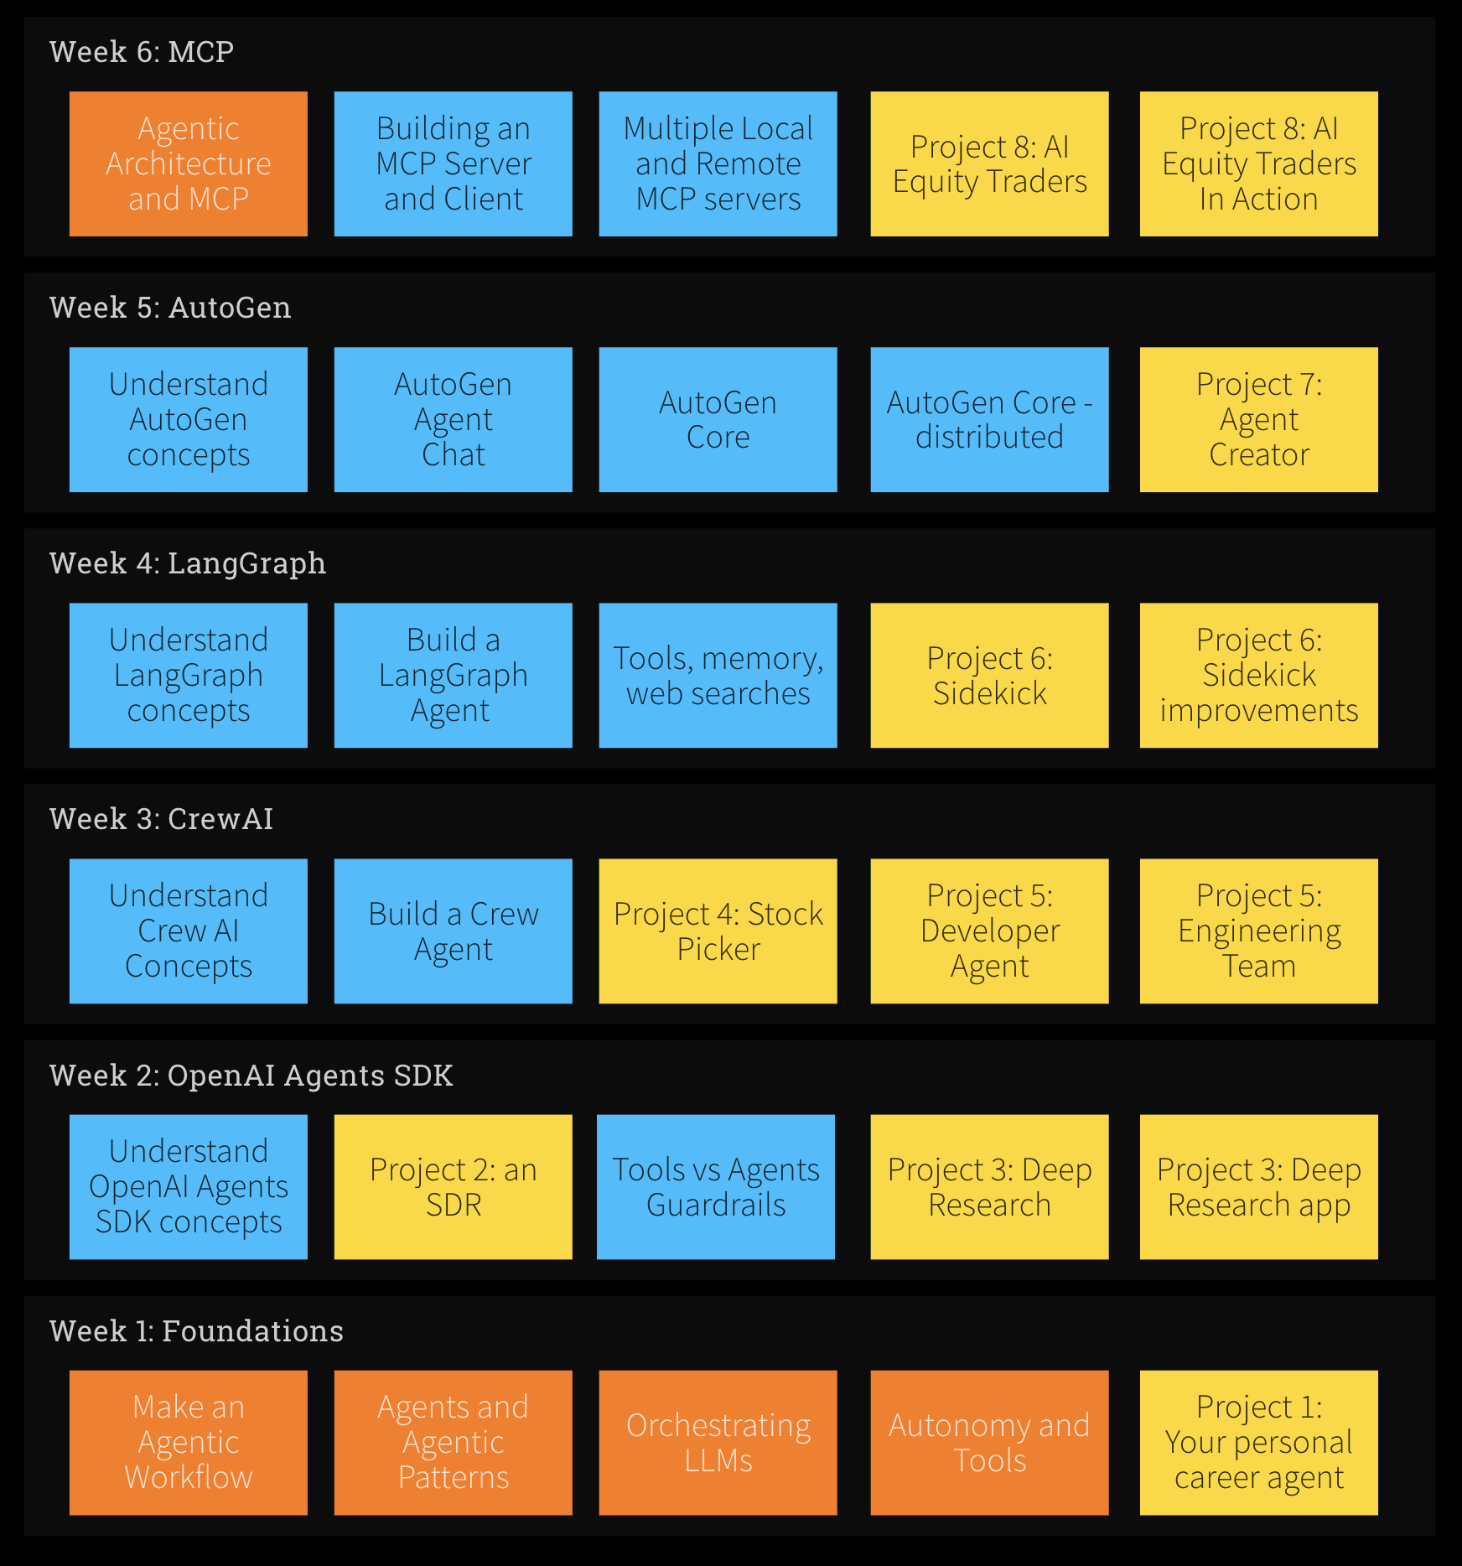

Links to slides for each day

Week 1
https://www.beautiful.ai/player/-OObqarFBop94NAGUc0s
https://www.beautiful.ai/player/-OObqfScucZ13Q30ntca
https://www.beautiful.ai/player/-OObqld0Bqr4huYtIi0L
https://www.beautiful.ai/player/-OObqtabI-tfNqdxERq1
https://www.beautiful.ai/player/-OObqw2tVZKfWgXIDM-a

Week 2
https://www.beautiful.ai/player/-OObr-UWxNuF7zSTf_lo
https://www.beautiful.ai/player/-OObrAVjBuWAsulUV1Rn
https://www.beautiful.ai/player/-OObrEASBjnYsC0Z9akG
https://www.beautiful.ai/player/-OObrK9yFJ6NFRnLUTUw
https://www.beautiful.ai/player/-OObrMdt9yNjlLdu7JF9

Week 3
https://www.beautiful.ai/player/-OObrP__iZjs_9k7skTI
https://www.beautiful.ai/player/-OObrS17gn5kHsyx_Crc
https://www.beautiful.ai/player/-OObrV-y8sVqjbMi6Jd3
https://www.beautiful.ai/player/-OObrazOK6Dk8aiDvo9a
https://www.beautiful.ai/player/-OObreXDmklghb3yldgE

Week 4
https://www.beautiful.ai/player/-OObrrYYTBYHEoN-pXQH
https://www.beautiful.ai/player/-OObrxIBzX_LjiPjlxIx
https://www.beautiful.ai/player/-OObrxMFjZMtX9-a60_v
https://www.beautiful.ai/player/-OObs2pUpTn07ipGgTk0
https://www.beautiful.ai/player/-OObs2vUOA539jkkNZ-n

Week 5
https://www.beautiful.ai/player/-OObs8vx_Ic2KZecrAgy
https://www.beautiful.ai/player/-OObsB_WAVx4CLdodO0n
https://www.beautiful.ai/player/-OObsB46YECIKnzMyXmS
https://www.beautiful.ai/player/-OObsE5TM7bwZA41HTwF
https://www.beautiful.ai/player/-OObsJEmdiZVqHPo4EcF

Week 6
https://www.beautiful.ai/player/-OObsMmFcBnMGEAUMbLM
https://www.beautiful.ai/player/-OObsNpdOn3dCzapHFGv
https://www.beautiful.ai/player/-OObsQ41g56MI8KqZyT0
https://www.beautiful.ai/player/-OObsVuyVBsGbYwDeObN
https://www.beautiful.ai/player/-OObsVhhrBEuwlcPtfYW

